**Mathematics Methods Unit 4 2019**

**Investigation 3: Pressure and Balloons**

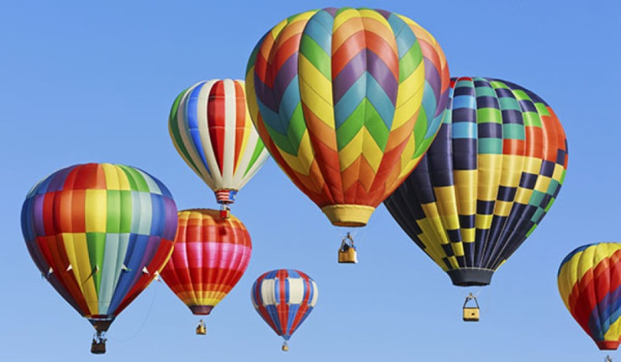

This investigation comprises two parts.

**Part A** is the Take Home Section of this assignment due to be handed in on Wednesday 24 July. Students are given time to work on finding the relationship between two variables that are not in a linear relationship. The marks allocated in this section will account for 0% of the task.

**Part B** is the validation section of the report and will take place in class on the Friday of the week that the report is due. This mark will constitute 100% of the total investigation mark. Notes will not be allowed in this section, however calculators will be allowed.

**Name: _________________________________** **Marks:____ / 25**

**Part A due Wednesday 24 July**

In this section we will examine some data about approximate barometric pressure , $P$ cm of mercury, recorded in a balloon flight in the USA, at an altitude $x$ km above sea level.

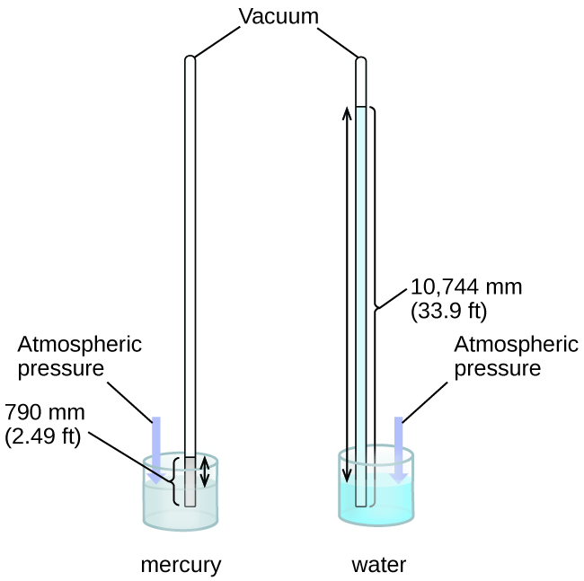Mercury is commonly used in barometers because its high density means the height of the column can be a reasonable size to measure atmospheric pressure. A barometer using water, for instance, would need to be 13.6 times taller than a mercury barometer to obtain the same pressure difference.

Data relevant to the flight.

|  |  |  |  |  |  |  |  |  |
| --- | --- | --- | --- | --- | --- | --- | --- | --- |
| $x$**(km)** | 0 | 4.6 | 7.9 | 13.1 | 16.2 | 19.8 | 22.9 | 29.0 |
| $P$**(cm)** | 76 | 42.9 | 25.2 | 12.4 | 7.2 | 3.8 | 2.7 | 1.0 |

**a)** On the grid below, choosing the scale of your axes carefully, plot the above points on a graph. (***x*** is the independent variable and ***P*** is the dependent variable). Complete a smooth curve by joining the points plotted. **[7]**

|  |  |  |  |  |  |  |  |  |  |  |  |  |  |  |  |  |  |  |  |  |  |  |  |  |  |  |  |  |  |  |  |
| --- | --- | --- | --- | --- | --- | --- | --- | --- | --- | --- | --- | --- | --- | --- | --- | --- | --- | --- | --- | --- | --- | --- | --- | --- | --- | --- | --- | --- | --- | --- | --- |
|  |  |  |  |  |  |  |  |  |  |  |  |  |  |  |  |  |  |  |  |  |  |  |  |  |  |  |  |  |  |  |  |
|  |  |  |  |  |  |  |  |  |  |  |  |  |  |  |  |  |  |  |  |  |  |  |  |  |  |  |  |  |  |  |  |
|  |  |  |  |  |  |  |  |  |  |  |  |  |  |  |  |  |  |  |  |  |  |  |  |  |  |  |  |  |  |  |  |
|  |  |  |  |  |  |  |  |  |  |  |  |  |  |  |  |  |  |  |  |  |  |  |  |  |  |  |  |  |  |  |  |
|  |  |  |  |  |  |  |  |  |  |  |  |  |  |  |  |  |  |  |  |  |  |  |  |  |  |  |  |  |  |  |  |
|  |  |  |  |  |  |  |  |  |  |  |  |  |  |  |  |  |  |  |  |  |  |  |  |  |  |  |  |  |  |  |  |
|  |  |  |  |  |  |  |  |  |  |  |  |  |  |  |  |  |  |  |  |  |  |  |  |  |  |  |  |  |  |  |  |
|  |  |  |  |  |  |  |  |  |  |  |  |  |  |  |  |  |  |  |  |  |  |  |  |  |  |  |  |  |  |  |  |
|  |  |  |  |  |  |  |  |  |  |  |  |  |  |  |  |  |  |  |  |  |  |  |  |  |  |  |  |  |  |  |  |
|  |  |  |  |  |  |  |  |  |  |  |  |  |  |  |  |  |  |  |  |  |  |  |  |  |  |  |  |  |  |  |  |
|  |  |  |  |  |  |  |  |  |  |  |  |  |  |  |  |  |  |  |  |  |  |  |  |  |  |  |  |  |  |  |  |
|  |  |  |  |  |  |  |  |  |  |  |  |  |  |  |  |  |  |  |  |  |  |  |  |  |  |  |  |  |  |  |  |
|  |  |  |  |  |  |  |  |  |  |  |  |  |  |  |  |  |  |  |  |  |  |  |  |  |  |  |  |  |  |  |  |
|  |  |  |  |  |  |  |  |  |  |  |  |  |  |  |  |  |  |  |  |  |  |  |  |  |  |  |  |  |  |  |  |
|  |  |  |  |  |  |  |  |  |  |  |  |  |  |  |  |  |  |  |  |  |  |  |  |  |  |  |  |  |  |  |  |
|  |  |  |  |  |  |  |  |  |  |  |  |  |  |  |  |  |  |  |  |  |  |  |  |  |  |  |  |  |  |  |  |
|  |  |  |  |  |  |  |  |  |  |  |  |  |  |  |  |  |  |  |  |  |  |  |  |  |  |  |  |  |  |  |  |
|  |  |  |  |  |  |  |  |  |  |  |  |  |  |  |  |  |  |  |  |  |  |  |  |  |  |  |  |  |  |  |  |
|  |  |  |  |  |  |  |  |  |  |  |  |  |  |  |  |  |  |  |  |  |  |  |  |  |  |  |  |  |  |  |  |
|  |  |  |  |  |  |  |  |  |  |  |  |  |  |  |  |  |  |  |  |  |  |  |  |  |  |  |  |  |  |  |  |

**b)** What type of relationship is this likely to be, based on the curve you have drawn ? **[11]**

Listing the data in the Statistics Menu of your Graphic Calculator and then graphing the best fit shows that Quartic is a better fit than Cubic which is a better fit than Quadratic. Could it be an exponential relationship ?

To investigate this possibility redraw your graph with the axes $x$ km and $lnP$ cm

(Choose your scale carefully.)

|  |  |  |  |  |  |  |  |  |
| --- | --- | --- | --- | --- | --- | --- | --- | --- |
| ***x* (km)** | 0 | 4.6 | 7.9 | 13.1 | 16.2 | 19.8 | 22.9 | 29.0 |
| ***P (cm)*** | 76 | 42.9 | 25.2 | 12.4 | 7.2 | 3.8 | 2.7 | 1.0 |
| ***ln P*** |  |  |  |  |  |  |  |  |

|  |  |  |  |  |  |  |  |  |  |  |  |  |  |  |  |  |  |  |  |  |  |  |  |  |  |  |  |  |  |  |  |
| --- | --- | --- | --- | --- | --- | --- | --- | --- | --- | --- | --- | --- | --- | --- | --- | --- | --- | --- | --- | --- | --- | --- | --- | --- | --- | --- | --- | --- | --- | --- | --- |
|  |  |  |  |  |  |  |  |  |  |  |  |  |  |  |  |  |  |  |  |  |  |  |  |  |  |  |  |  |  |  |  |
|  |  |  |  |  |  |  |  |  |  |  |  |  |  |  |  |  |  |  |  |  |  |  |  |  |  |  |  |  |  |  |  |
|  |  |  |  |  |  |  |  |  |  |  |  |  |  |  |  |  |  |  |  |  |  |  |  |  |  |  |  |  |  |  |  |
|  |  |  |  |  |  |  |  |  |  |  |  |  |  |  |  |  |  |  |  |  |  |  |  |  |  |  |  |  |  |  |  |
|  |  |  |  |  |  |  |  |  |  |  |  |  |  |  |  |  |  |  |  |  |  |  |  |  |  |  |  |  |  |  |  |
|  |  |  |  |  |  |  |  |  |  |  |  |  |  |  |  |  |  |  |  |  |  |  |  |  |  |  |  |  |  |  |  |
|  |  |  |  |  |  |  |  |  |  |  |  |  |  |  |  |  |  |  |  |  |  |  |  |  |  |  |  |  |  |  |  |
|  |  |  |  |  |  |  |  |  |  |  |  |  |  |  |  |  |  |  |  |  |  |  |  |  |  |  |  |  |  |  |  |
|  |  |  |  |  |  |  |  |  |  |  |  |  |  |  |  |  |  |  |  |  |  |  |  |  |  |  |  |  |  |  |  |
|  |  |  |  |  |  |  |  |  |  |  |  |  |  |  |  |  |  |  |  |  |  |  |  |  |  |  |  |  |  |  |  |
|  |  |  |  |  |  |  |  |  |  |  |  |  |  |  |  |  |  |  |  |  |  |  |  |  |  |  |  |  |  |  |  |
|  |  |  |  |  |  |  |  |  |  |  |  |  |  |  |  |  |  |  |  |  |  |  |  |  |  |  |  |  |  |  |  |
|  |  |  |  |  |  |  |  |  |  |  |  |  |  |  |  |  |  |  |  |  |  |  |  |  |  |  |  |  |  |  |  |
|  |  |  |  |  |  |  |  |  |  |  |  |  |  |  |  |  |  |  |  |  |  |  |  |  |  |  |  |  |  |  |  |
|  |  |  |  |  |  |  |  |  |  |  |  |  |  |  |  |  |  |  |  |  |  |  |  |  |  |  |  |  |  |  |  |
|  |  |  |  |  |  |  |  |  |  |  |  |  |  |  |  |  |  |  |  |  |  |  |  |  |  |  |  |  |  |  |  |
|  |  |  |  |  |  |  |  |  |  |  |  |  |  |  |  |  |  |  |  |  |  |  |  |  |  |  |  |  |  |  |  |
|  |  |  |  |  |  |  |  |  |  |  |  |  |  |  |  |  |  |  |  |  |  |  |  |  |  |  |  |  |  |  |  |
|  |  |  |  |  |  |  |  |  |  |  |  |  |  |  |  |  |  |  |  |  |  |  |  |  |  |  |  |  |  |  |  |
|  |  |  |  |  |  |  |  |  |  |  |  |  |  |  |  |  |  |  |  |  |  |  |  |  |  |  |  |  |  |  |  |

**c)** Draw your line of best fit on the graph by inspection. **[4]**

You should now be able to give a linear rule for your line of best fit.

The log-linear relationship can be used to arrive at the exponential function we are looking for.

The exponential function could be modelled to **P = P0 ekx** where **P0**  is the Pressure at 0 altitude.

If we take natural logs of both sides of the function **P = P0 ekx** we get

ln P = ln P0 + ln ekx

⇒ ln P = ln P0 + kx.ln e (ln e =1)

⇒ ln P = ln P0 + kx

Hence if we graph ln P as the y-co-ordinate, against x, we have a line with the following features:

**gradient = k**, and **y-intercept = ln P0**

**d)** Convert your linear rule to an exponential one in the form **P = P0 ekx** , taking your P0 valueto one decimal place and your gradient k to three decimalplaces for greater accuracy. **[3]**